# **Project Step 1-XU YAN 17JAN2021**

* **Due** Sunday by 11:59pm

## Concept Investigation

### **Description**

Begin thinking about the kind of project to showcase. List the specific functionalities of the chosen kind of project, and some preliminary investigation toward implementing the project. All projects should include:

* a data component
* and an interface component

The deliverable should be a two-three-page document listing at least three specific project ideas, and a short description of the characteristics of each project.

***Project 1 Gobang Game with computer***

Gobang is a two-player abstract strategy game generally played with Go pieces on a 19*19 Go board.

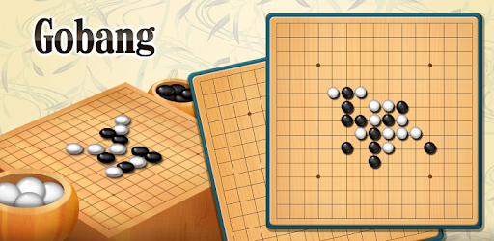The objective of the game is to be the first player to create a sequence of five same-colored pieces vertically, horizontally, or diagonally.

Players alternate turn to place their piece on an empty intersection in the board.

In Gobang, a player can capture and remove opponent’s pieces if the player makes a move and surrounds exactly two of the opponent’s pieces. A player can place two pieces between opponent’s pieces, and this will not be captured.

UI design

* Picture Box-create the chessboard,20*20
* Start Button
* Reset Button
* Label-show the game status

Method

The game finishes in one of the following two conditions

* A player creates a sequence of 5 consecutive pieces vertically, horizontally, or diagonally.
* A player captures 5 pairs of opponent’s pieces.

Output

Judge which player(computer) win the game and give out the result.

***Project 2 Inventory management system with C#***

Inventory Management System in C# backend SQL SERVER is going to create also known stock management system and it is totally dynamic system.

It can work in different environment, for example, a store inventory management system or a chain sales management system.

Functions of the inventory management system, included but not limited:

* user can login
* user can add new user in this system
* user can add unit (KG, LITRE, GRAMS, PIECES etc. and many more)
* user can add purchase party info
* user can add products information like (product name, product amount, today's date, quantity, purchase party name, purchase type (CASH, CHEQUE), expiry date etc.)
* user can add record when purchase an item, so it will increase the stock of items and user can edit and delete items
* user can sell items and can generate bills also (when user sold items then stock will decrease)
* user can add expiry date of products also if needed then, so user can get notification before few days ago of expire date.
* user can see the information of stocks also
* user can see the purchase report of items between two dates
* user can see the sales report of items between two dates
* user can see the report of any party from whom they purchase products
* user can see the day to day selling and between 2 dates selling report.
* user can see the current stock of items and print the report of that items.

Method

Find stock-purchase report-selling report

***Project 3 Create a reminder for an appointment item***

Outlook provides a way to set a reminder for an appointment by using the Reminder Set property of the Appointment Item object. This property indicates whether a reminder has been created for the appointment. Setting the Reminder Set property to true creates a reminder and setting it to false removes the reminder.

Method

Import the Outlook namespace.

Reference and example

* <https://docs.microsoft.com/en-us/office/client-developer/outlook/pia/how-to-create-a-reminder-for-an-appointment-item>
* https://www.channelinsider.com/tech-analysis/Creating-an-Appointment-Reminder-System-in-C